Part 1:
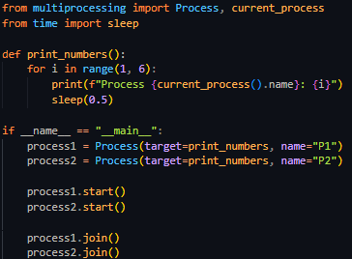
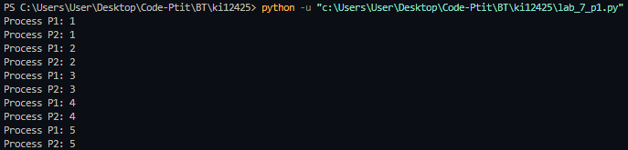
Part 2:
Without synchronization, the counter value will likely be less than 400.
With the TestAndSetLock, the final counter value will always be 400(4 processes × 100 increments each).

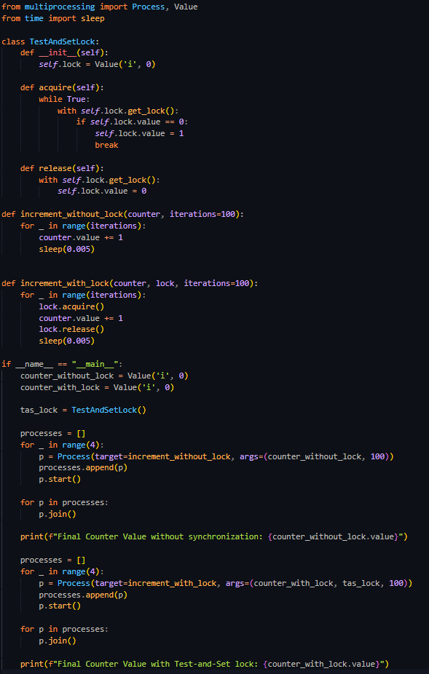

Part 3:

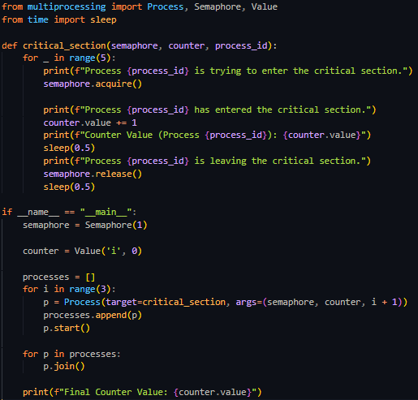
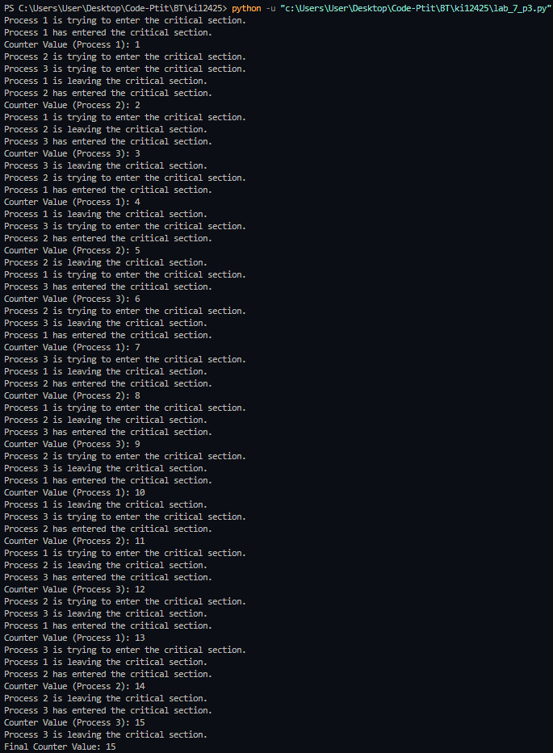
Part 4:
Unsynchronized version:
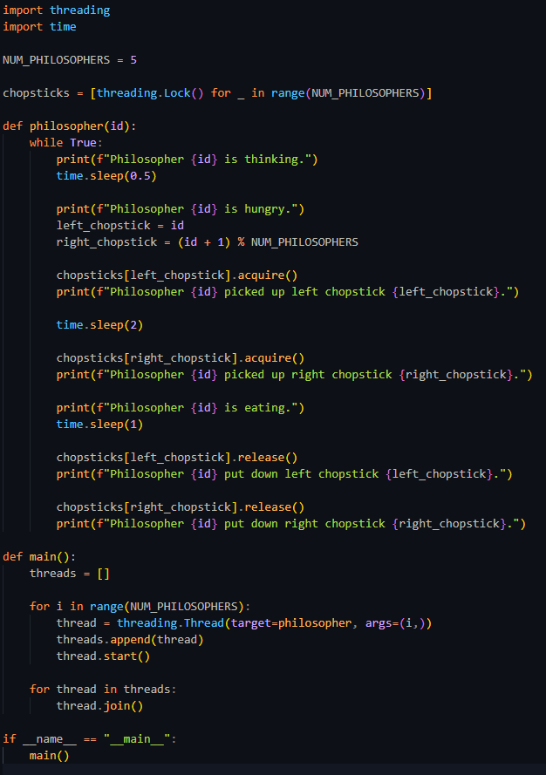
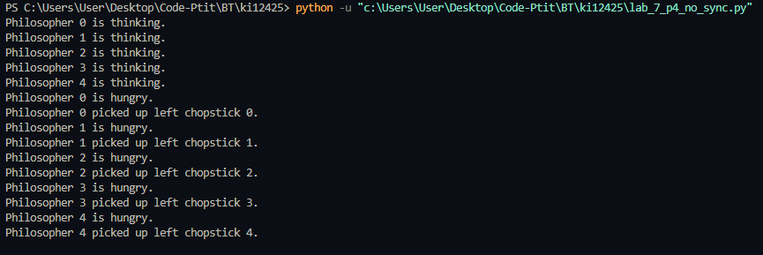
All philosophers pick up their left chopstick, no one can have their right chopstick and all of them will always be hungry.
Synchronized version:
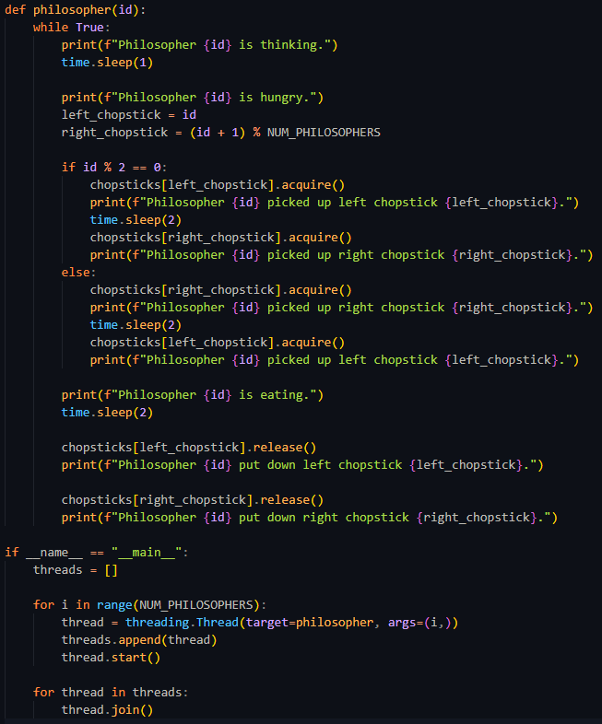
Philosophers alternate between picking up the left and right chopsticks. Even philosophers (0, 2, 4) always pick up the left chopstick first, while odd philosophers (1, 3) pick up the right chopstick first. This approach prevents the circular wait condition, where all philosophers could end up waiting indefinitely for each other’s chopsticks.

